

Mobile Application Development

Lab 3



Muhammad daniyal Qureshi

021-18-0009

BSCS-VII

Contents

Activity 1: Activity Life Cycle 1

**Layout** 1

**Logic Code** 2

**Output** 4

Activity 2: Mood Game 5

**Layout** 5

**Logic Code** 6

**Output** 7

Activity 3: Coffee Ordering App 9

**Layout** 9

**Logic Code** 12

**Output** 14

Activity 4: Calculator 16

**Layout** 16

**Logic Code** 23

**Output** 27

Activity 5: Hangman 29

**Layout** 29

**Logic Code** 31

**Android Manifest File** 34

**Output** 34

# Activity 1: Activity Life Cycle

## **Layout**

<?xml version="1.0" encoding="utf-8"?>

<androidx.constraintlayout.widget.ConstraintLayout xmlns:android="http://schemas.android.com/apk/res/android"

    xmlns:app="http://schemas.android.com/apk/res-auto"

    xmlns:tools="http://schemas.android.com/tools"

    android:layout_width="match_parent"

    android:layout_height="match_parent"

    tools:context=".MainActivity">

    <TextView

        android:id="@+id/textView"

        android:layout_width="wrap_content"

        android:layout_height="wrap_content"

        android:layout_marginStart="52dp"

        android:layout_marginLeft="52dp"

        android:layout_marginTop="60dp"

        android:maxLines="20"

        android:text="TextView"

        android:textSize="18sp"

        app:layout_constraintStart_toStartOf="parent"

        app:layout_constraintTop_toTopOf="parent" />

</androidx.constraintlayout.widget.ConstraintLayout>

## **Logic Code**

package com.example.activitylifecycle;

import androidx.appcompat.app.AppCompatActivity;

import android.os.Bundle;

import android.view.Window;

import android.widget.TextView;

public class MainActivity extends AppCompatActivity {

    TextView txt;

    @Override

    protected void onCreate(Bundle savedInstanceState) {

        super.onCreate(savedInstanceState);

        setContentView(R.layout.activity_main);

        txt=findViewById(R.id.textView);

        txt.setText("Application is in creation state");

    }

    @Override

    protected void onStart() {

        super.onStart();

        txt.setText(txt.getText().toString()+"\nApplication is in start state");

    }

    @Override

    protected void onResume() {

        super.onResume();

        txt.setText(txt.getText().toString()+"\nApplication is in resume state");

    }

    @Override

    protected void onPause() {

        super.onPause();

        txt.setText(txt.getText().toString()+"\nApplication is in pause state");

    }

    @Override

    protected void onStop() {

        super.onStop();

        txt.setText(txt.getText().toString()+"\nApplication is in stop state");

    }

    @Override

    protected void onRestart() {

        super.onRestart();

        txt.setText(txt.getText().toString()+"\nApplication is in restart state");

    }

    @Override

    protected void onDestroy() {

        super.onDestroy();

        txt.setText(txt.getText().toString()+"\nApplication is in destroy state");

    }

## **Output**

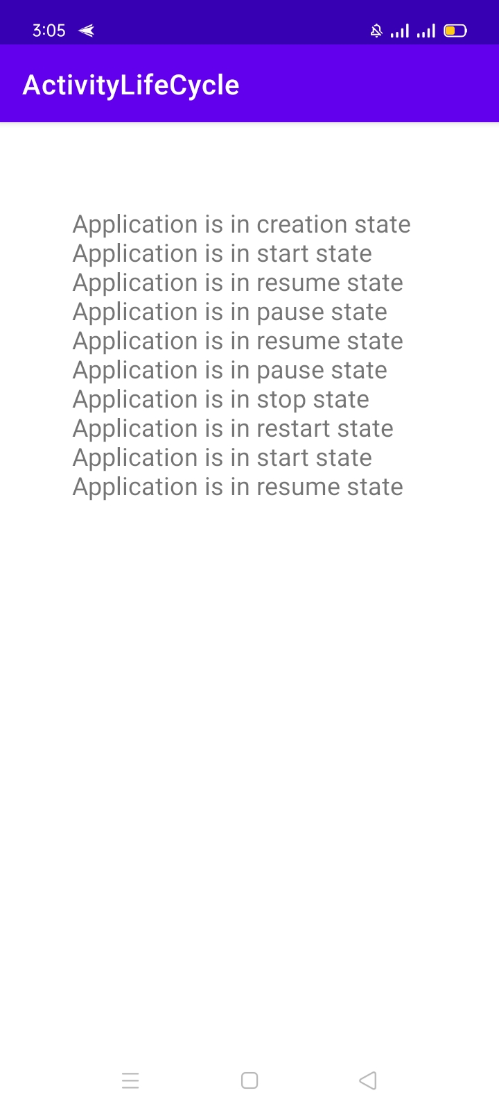

# Activity 2: Mood Game

## **Layout**

<?xml version="1.0" encoding="utf-8"?>

<androidx.constraintlayout.widget.ConstraintLayout xmlns:android="http://schemas.android.com/apk/res/android"

    xmlns:app="http://schemas.android.com/apk/res-auto"

    xmlns:tools="http://schemas.android.com/tools"

    android:layout_width="match_parent"

    android:layout_height="match_parent"

    tools:context=".MainActivity">

    <LinearLayout

        android:layout_width="match_parent"

        android:layout_height="match_parent"

        android:orientation="horizontal"

        app:layout_constraintTop_toTopOf="parent"

        android:background="#D3D3D3"

        >

        <ImageView

            android:id="@+id/img"

            android:layout_width="wrap_content"

            android:layout_height="wrap_content"

            android:layout_weight="1"

            app:srcCompat="@drawable/hungry"

            />

    </LinearLayout>

    <LinearLayout

        android:id="@+id/linearLayout"

        android:layout_width="match_parent"

        android:layout_height="wrap_content"

        android:background="@color/purple_200"

        android:orientation="vertical"

        app:layout_constraintBottom_toBottomOf="parent"

        tools:layout_editor_absoluteX="0dp">

        <TextView

            android:id="@+id/text"

            android:layout_width="match_parent"

            android:layout_height="wrap_content"

            android:text="  I am so hungry"

            android:textColor="@color/white"

            android:textSize="40sp" />

        <Button

            android:id="@+id/btn"

            android:layout_width="200dp"

            android:layout_height="wrap_content"

            android:layout_marginLeft="28dp"

            android:layout_marginBottom="20dp"

            android:text="EAT COOKIE"

            android:textColor="@color/white"

            android:textSize="20sp"

            android:onClick="change"

            />

    </LinearLayout>

</androidx.constraintlayout.widget.ConstraintLayout>

## **Logic Code**

package com.example.mood_game;

import androidx.appcompat.app.AppCompatActivity;

import android.os.Bundle;

import android.view.View;

import android.widget.Button;

import android.widget.ImageView;

import android.widget.TextView;

public class MainActivity extends AppCompatActivity {

    @Override

    protected void onCreate(Bundle savedInstanceState) {

        super.onCreate(savedInstanceState);

        setContentView(R.layout.activity_main);

    }

    public void change(View view) {

        Button btn = (Button) view;

        btn.setText("Done");

        ImageView img = (ImageView) findViewById(R.id.img);

        img.setImageResource(R.drawable.full);

        TextView txt = (TextView) findViewById(R.id.text);

        txt.setText("I am so full");

    }

}

## **Output**



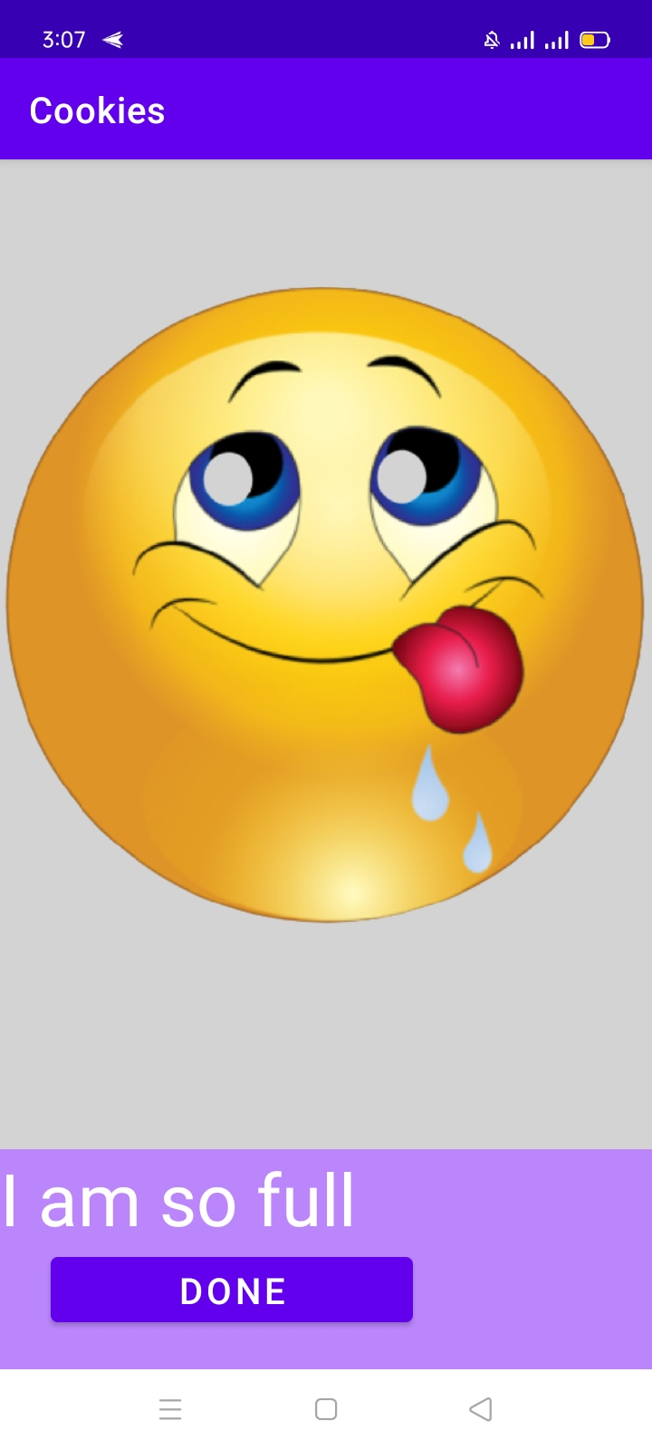

# Activity 3: Coffee Ordering App

## **Layout**

<?xml version="1.0" encoding="utf-8"?>

<LinearLayout xmlns:android="http://schemas.android.com/apk/res/android"

    xmlns:app="http://schemas.android.com/apk/res-auto"

    xmlns:tools="http://schemas.android.com/tools"

    android:layout_width="match_parent"

    android:layout_height="match_parent"

    android:background="#F7EAC1"

    android:orientation="vertical"

    tools:context=".MainActivity">

    <ImageView

        android:id="@+id/imageView"

        android:layout_width="match_parent"

        android:layout_height="90dp"

        android:layout_weight="0"

        app:srcCompat="@drawable/coffee2b" />

    <TextView

        android:id="@+id/textView"

        android:layout_width="wrap_content"

        android:layout_height="wrap_content"

        android:layout_gravity="center"

        android:layout_weight="0"

        android:gravity="center"

        android:textStyle="bold"

        android:textColor="@color/black"

        android:text="choose Toppings :"

        android:textSize="30sp" />

    <LinearLayout

        android:layout_width="match_parent"

        android:layout_height="wrap_content"

        android:layout_weight="0"

        android:gravity="center"

        android:orientation="horizontal">

        <CheckBox

            android:id="@+id/checkBox"

            android:layout_width="wrap_content"

            android:layout_height="wrap_content"

            android:layout_weight="0"

            android:tag="cream"

            android:text="Cream" />

        <CheckBox

            android:id="@+id/checkBox2"

            android:layout_width="wrap_content"

            android:layout_height="wrap_content"

            android:layout_weight="0"

            android:tag="chocolate"

            android:text="Chocolate" />

    </LinearLayout>

    <TextView

        android:id="@+id/textView2"

        android:layout_width="wrap_content"

        android:layout_height="wrap_content"

        android:layout_gravity="center"

        android:layout_weight="0"

        android:text="Quantity"

        android:textStyle="bold"

        android:textColor="@color/black"

        android:textSize="30sp" />

    <LinearLayout

        android:layout_width="match_parent"

        android:layout_height="wrap_content"

        android:layout_weight="0"

        android:gravity="center"

        android:orientation="horizontal">

        <Button

            android:id="@+id/button2"

            android:layout_width="wrap_content"

            android:layout_height="wrap_content"

            android:layout_weight="0"

            android:onClick="sub"

            android:tag="sub"

            android:text="-" />

        <TextView

            android:id="@+id/textView3"

            android:layout_width="wrap_content"

            android:layout_height="wrap_content"

            android:layout_weight="0"

            android:text="0"

            android:textSize="24sp" />

        <Button

            android:id="@+id/button3"

            android:layout_width="wrap_content"

            android:layout_height="wrap_content"

            android:layout_weight="0"

            android:onClick="add"

            android:tag="add"

            android:text="+" />

    </LinearLayout>

    <Button

        android:id="@+id/button4"

        android:layout_width="wrap_content"

        android:layout_height="wrap_content"

        android:layout_gravity="center"

        android:layout_weight="0"

        android:text="Order"

        android:onClick="ShowSummary"

        />

    <TextView

        android:id="@+id/textView4"

        android:layout_width="wrap_content"

        android:layout_height="wrap_content"

        android:layout_gravity="center"

        android:layout_weight="0"

        android:text="ORDER SUMMARY"

        android:textSize="30sp" />

    <TextView

        android:id="@+id/summary"

        android:layout_width="wrap_content"

        android:layout_height="wrap_content"

        android:layout_gravity="center"

        android:layout_weight="0"

        android:text=""

        android:layout_marginTop="20dp"

        android:maxLines="7"

        android:textSize="20sp" />

</LinearLayout>

## **Logic Code**

package com.example.coffee_ordering;

import androidx.appcompat.app.AppCompatActivity;

import android.os.Bundle;

import android.view.View;

import android.widget.CheckBox;

import android.widget.TextView;

public class MainActivity extends AppCompatActivity {

    TextView txt;

    TextView summary;

    @Override

    protected void onCreate(Bundle savedInstanceState) {

        super.onCreate(savedInstanceState);

        setContentView(R.layout.activity_main);

        txt=(TextView)findViewById(R.id.textView3);

        summary=(TextView)findViewById(R.id.summary);

    }

    public void add(View view){

        int text=Integer.parseInt(txt.getText().toString())+1;

        txt.setText(""+text);

    }

    public void sub(View view){

        int text=Integer.parseInt(txt.getText().toString())-1;

        if(text>=0)

            txt.setText(""+text);

    }

    public void ShowSummary(View view){

         String cream="no";

         String choc="no";

         int qty=Integer.parseInt(txt.getText().toString());

         float amount=qty*4;

         CheckBox bx1=(CheckBox)findViewById(R.id.checkBox);

         CheckBox bx2=(CheckBox)findViewById(R.id.checkBox2);

         if(bx1.isChecked()) {

             cream = "yes";

            amount+=0.50*qty;

         }

         if(bx2.isChecked()) {

             choc = "yes";

            amount+=qty;

         }

        summary.setText("Add whipped cream ?"+cream+"\nAdd chocolate ?"+choc+"\nQuantity: "+qty

        +"\n\nPrice :$"+amount+"\nTHANK YOU!");

    }

}

## **Output**

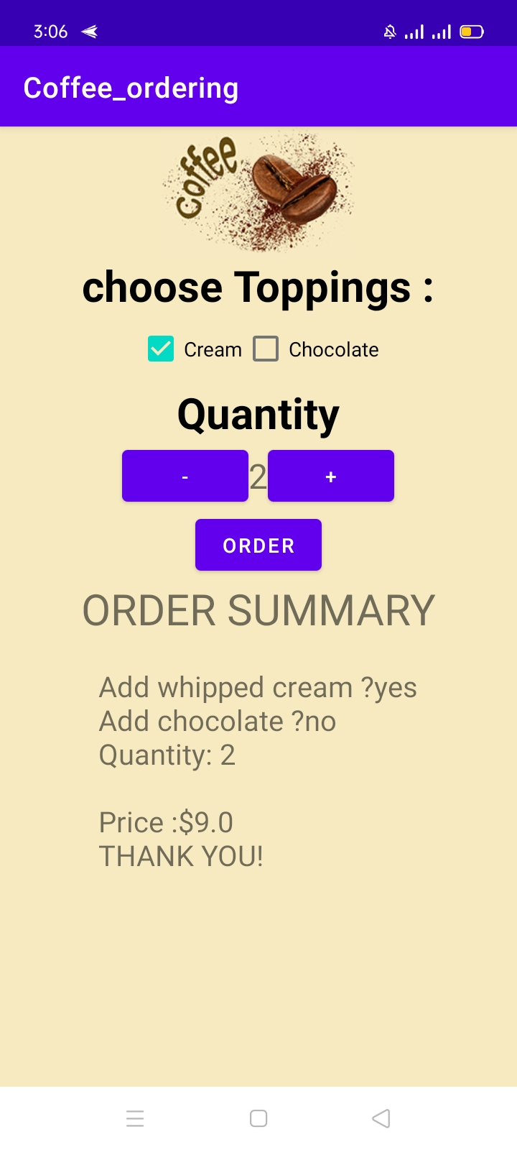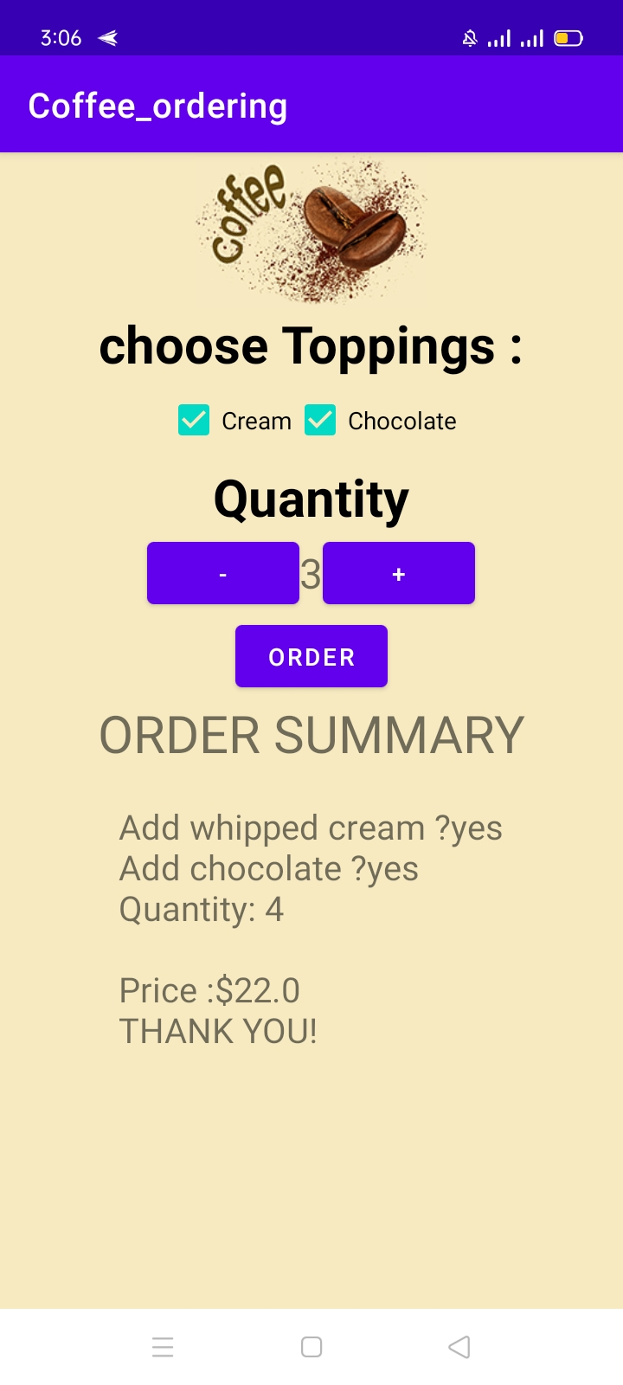

# Activity 4: Calculator

## **Layout**

<?xml version="1.0" encoding="utf-8"?>

<TableLayout xmlns:android="http://schemas.android.com/apk/res/android"

    xmlns:app="http://schemas.android.com/apk/res-auto"

    xmlns:tools="http://schemas.android.com/tools"

    android:layout_width="match_parent"

    android:layout_height="match_parent"

    tools:context=".MainActivity"

    >

    <TableRow

        android:layout_width="match_parent"

        android:layout_height="wrap_content"

        android:background="#DAA04A"

       android:gravity="right"

        >

        <TextView

            android:id="@+id/result"

            android:layout_width="wrap_content"

            android:layout_height="140dp"

            android:text=""

            android:textSize="40sp"

            android:gravity="center"

            />

    </TableRow>

    <TableRow

        android:layout_width="match_parent"

        android:layout_height="wrap_content"

        >

        <Button

            android:id="@+id/AC"

            android:layout_height="100dp"

            android:layout_width="0dp"

            android:layout_weight="2"

            android:background="#03A9F4"

            android:text="AC"

            android:textColor="@color/black"

            android:textSize="30sp"

            app:backgroundTint="#6877CC"

            android:layout_marginRight="5dp"

            android:onClick="clear"

            />

        <Button

            android:id="@+id/modulo"

            android:layout_height="100dp"

            android:layout_width="0dp"

            android:layout_weight="1"

            android:text="%"

            android:textSize="30sp"

            android:backgroundTint="#C0C0C0"

            android:textColor="@color/black"

            android:layout_marginRight="5dp"

            android:onClick="number"

            />

        <Button

            android:id="@+id/divide"

            android:layout_height="100dp"

            android:layout_weight="1"

            android:text="/"

            android:layout_width="0dp"

            android:textSize="30sp"

            android:backgroundTint="#C0C0C0"

            android:textColor="@color/black"

            android:layout_marginRight="5dp"

            android:onClick="number"

            />

    </TableRow>

    <TableRow

        android:layout_width="match_parent"

        android:layout_height="wrap_content"

        android:layout_marginTop="5dp"

        >

        <Button

            android:id="@+id/seven"

            android:layout_height="100dp"

            android:layout_weight="1"

            android:text="7"

            android:layout_width="0dp"

            android:textSize="30sp"

            android:backgroundTint="#C0C0C0"

            android:textColor="@color/black"

            android:layout_marginRight="5dp"

            android:onClick="number"

            />

        <Button

            android:id="@+id/eight"

            android:backgroundTint="#C0C0C0"

            android:layout_height="100dp"

            android:layout_weight="1"

            android:text="8"

            android:textSize="30sp"

            android:layout_width="0dp"

            android:textColor="@color/black"

            android:layout_marginRight="5dp"

            android:onClick="number"

            />

        <Button

            android:id="@+id/nine"

            android:layout_height="100dp"

            android:layout_weight="1"

            android:text="9"

            android:textSize="30sp"

            android:layout_width="0dp"

            android:backgroundTint="#C0C0C0"

            android:textColor="@color/black"

            android:layout_marginRight="5dp"

            android:onClick="number"

            />

        <Button

            android:id="@+id/multiply"

            android:layout_height="100dp"

            android:layout_weight="1"

            android:text="*"

            android:textSize="30sp"

            android:layout_width="0dp"

            android:backgroundTint="#C0C0C0"

            android:textColor="@color/black"

            android:layout_marginRight="5dp"

            android:onClick="number"

            />

    </TableRow>

    <TableRow

        android:layout_width="match_parent"

        android:layout_height="wrap_content"

        android:layout_marginTop="5dp"

        >

        <Button

            android:id="@+id/four"

            android:layout_height="100dp"

            android:layout_weight="1"

            android:text="4"

            android:layout_width="0dp"

            android:textSize="30sp"

            android:backgroundTint="#C0C0C0"

            android:textColor="@color/black"

            android:layout_marginRight="5dp"

            android:onClick="number"

            />

        <Button

            android:id="@+id/five"

            android:backgroundTint="#C0C0C0"

            android:layout_height="100dp"

            android:layout_weight="1"

            android:text="5"

            android:textSize="30sp"

            android:layout_width="0dp"

            android:textColor="@color/black"

            android:layout_marginRight="5dp"

            android:onClick="number"

            />

        <Button

            android:id="@+id/six"

            android:layout_height="100dp"

            android:layout_weight="1"

            android:text="6"

            android:textSize="30sp"

            android:layout_width="0dp"

            android:backgroundTint="#C0C0C0"

            android:textColor="@color/black"

            android:layout_marginRight="5dp"

            android:onClick="number"

            />

        <Button

            android:id="@+id/sub"

            android:layout_height="100dp"

            android:layout_weight="1"

            android:text="-"

            android:textSize="30sp"

            android:layout_width="0dp"

            android:backgroundTint="#C0C0C0"

            android:textColor="@color/black"

            android:layout_marginRight="5dp"

            android:onClick="number"

            />

    </TableRow>

    <TableRow

        android:layout_width="match_parent"

        android:layout_height="wrap_content"

        android:layout_marginTop="5dp"

        >

        <Button

            android:id="@+id/one"

            android:layout_height="100dp"

            android:layout_weight="1"

            android:text="1"

            android:layout_width="0dp"

            android:textSize="30sp"

            android:backgroundTint="#C0C0C0"

            android:textColor="@color/black"

            android:layout_marginRight="5dp"

            android:onClick="number"

            />

        <Button

            android:id="@+id/two"

            android:backgroundTint="#C0C0C0"

            android:layout_height="100dp"

            android:layout_weight="1"

            android:text="2"

            android:textSize="30sp"

            android:layout_width="0dp"

            android:textColor="@color/black"

            android:layout_marginRight="5dp"

            android:onClick="number"

            />

        <Button

            android:id="@+id/three"

            android:layout_height="100dp"

            android:layout_weight="1"

            android:text="3"

            android:textSize="30sp"

            android:layout_width="0dp"

            android:backgroundTint="#C0C0C0"

            android:textColor="@color/black"

            android:layout_marginRight="5dp"

            android:onClick="number"

            />

        <Button

            android:id="@+id/plus"

            android:layout_height="100dp"

            android:layout_weight="1"

            android:text="+"

            android:textSize="30sp"

            android:layout_width="0dp"

            android:backgroundTint="#C0C0C0"

            android:textColor="@color/black"

            android:layout_marginRight="5dp"

            android:onClick="number"

            />

    </TableRow>

    <TableRow

        android:layout_width="match_parent"

        android:layout_height="wrap_content"

        android:layout_marginTop="5dp"

        >

        <Button

            android:id="@+id/zero"

            android:layout_height="100dp"

            android:layout_weight="1"

            android:text="0"

            android:layout_width="0dp"

            android:textSize="30sp"

            android:backgroundTint="#C0C0C0"

            android:textColor="@color/black"

            android:layout_marginRight="5dp"

            android:onClick="number"

            />

        <Button

            android:id="@+id/equal"

            android:layout_height="100dp"

            android:layout_weight="1"

            android:text="="

            android:textSize="30sp"

            android:layout_width="0dp"

            android:textColor="@color/black"

            android:layout_marginRight="5dp"

            app:backgroundTint="#6877CC"

            android:onClick="result"

            />

    </TableRow>

</TableLayout>

## **Logic Code**

package com.example.calculator;

import java.util.Stack;

import androidx.appcompat.app.AppCompatActivity;

import android.os.Bundle;

import android.util.Log;

import android.view.View;

import android.widget.Button;

import android.widget.TextView;

public class MainActivity extends AppCompatActivity {

    TextView rs;

    @Override

    protected void onCreate(Bundle savedInstanceState) {

        super.onCreate(savedInstanceState);

        setContentView(R.layout.activity_main);

        rs=(TextView)findViewById(R.id.result);

    }

    public void number(View view){

        if(rs.getText().equals("Invalid Expression"))

            rs.setText("");

        Button btn=(Button)view;

        String text=rs.getText().toString()+btn.getText();

        rs.setText(text);

    }

    public void result(View view){

            String exp=rs.getText().toString().replace("%","*1/100*");

            try {

                rs.setText("" + evaluatePostfix(infixToPostfix(exp)));

            }

            catch (Exception e){

                rs.setText("Invalid Expression");

            }

    }

    public void clear(View view){

        rs.setText("");

    }

    public int Prec(char ch)

    {

        switch (ch)

        {

            case '+':

            case '-':

                return 1;

            case '*':

            case '/':

                return 2;

        }

        return -1;

    }

    public String infixToPostfix(String exp)

    {

        String result = "";

          Stack<Character> stack = new Stack<>();

        for (int i = 0; i<exp.length(); ++i)

        {

            char c = exp.charAt(i);

            if (Character.isDigit(c))

                result+= c;

            else // an operator is encountered

            {   result+=" ";

                while (!stack.isEmpty() && Prec(c)

                        <= Prec(stack.peek()))

                    result += stack.pop();

                stack.push(c);

            }

        }

        while (!stack.isEmpty()){

            result += stack.pop();

        }

        return result;

    }

    public  float evaluatePostfix(String exp)

    {

        //create a stack

        Stack<Float> stack = new Stack<>();

        String d="";

        // Scan all characters on e by one

        for(int i = 0; i < exp.length(); i++)

        {

            char c = exp.charAt(i);

            if(c == ' '){

                if(d.length()>0)

                    stack.push(Float.parseFloat(d));

                d="";

            }

            else if(Character.isDigit(c))

                d+=c;

          else

            {

                System.out.println(c);

                if(d.length()>0) {

                    stack.push(Float.parseFloat(d));

                    d="";

                }

                float val1 = stack.pop();

                float val2 = stack.pop();

                switch(c)

                {

                    case '+':

                        stack.push(val2+val1);

                        break;

                    case '-':

                        stack.push(val2- val1);

                        break;

                    case '/':

                        stack.push(val2/val1 );

                        break;

                    case '*':

                        stack.push(val2*val1);

                        break;

                }

            }

        }

        return stack.pop();

    }

}

## **Output**

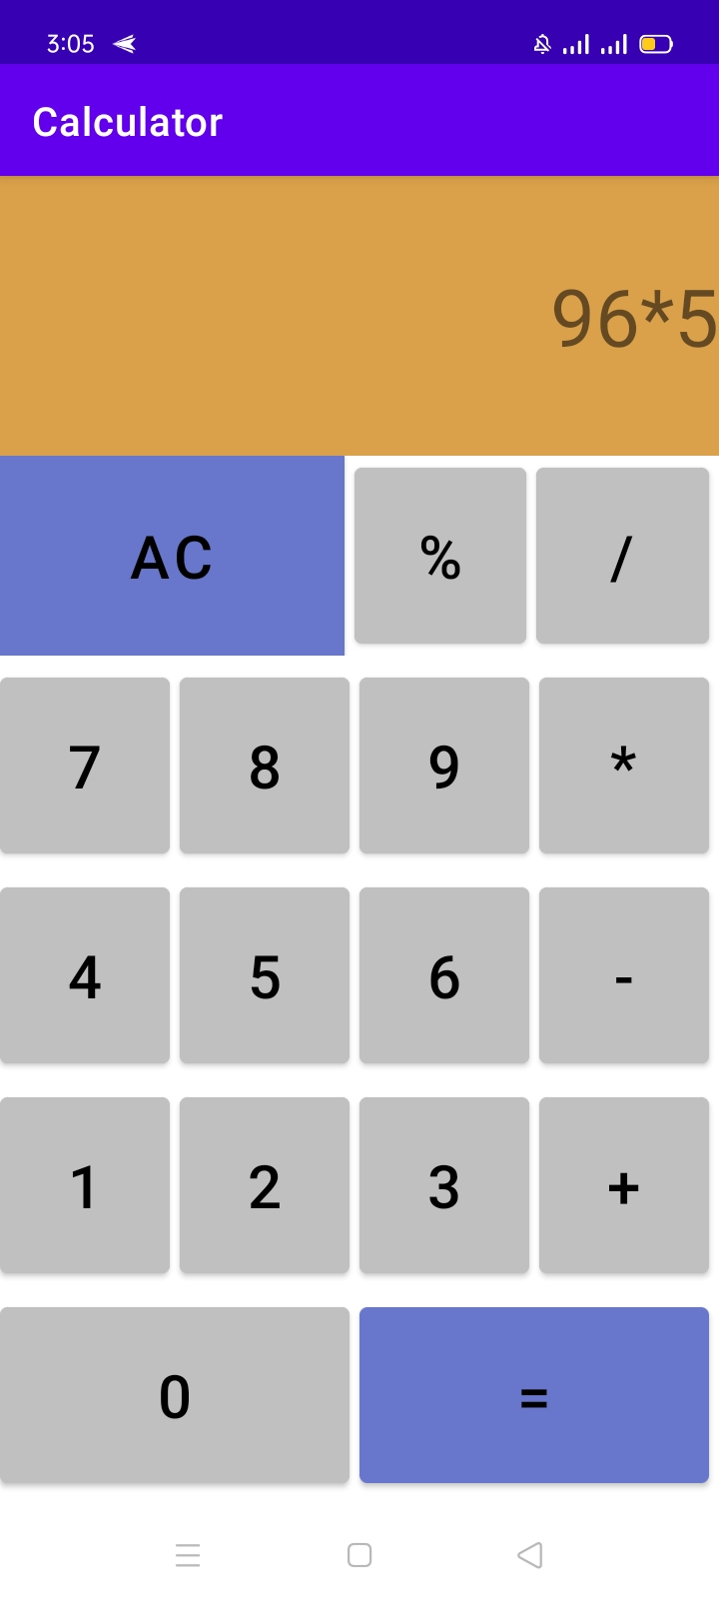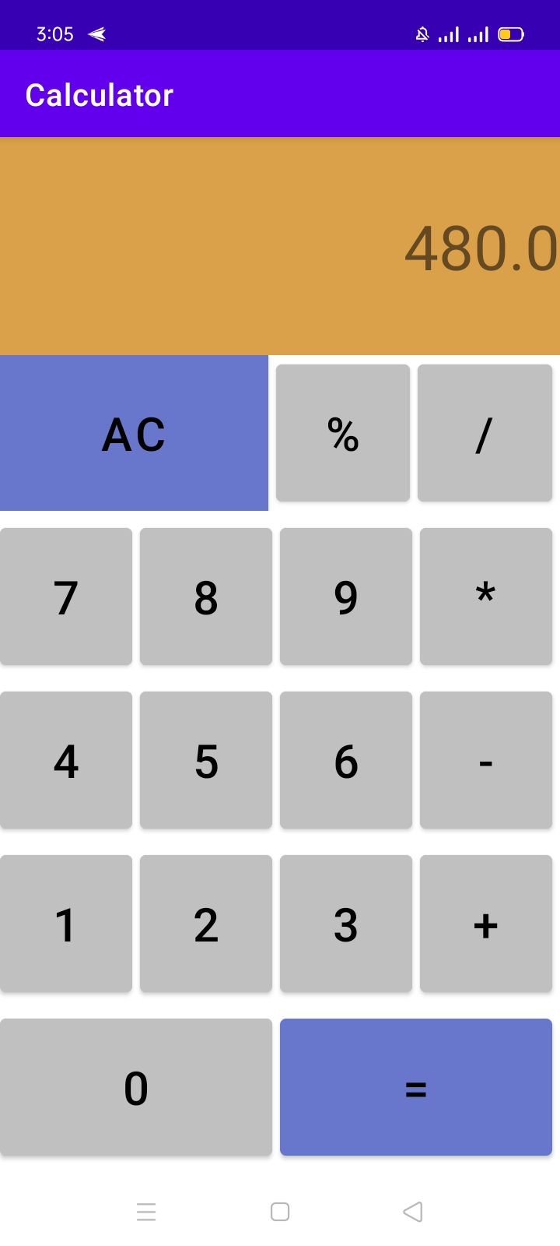

# Activity 5: Hangman

## **Layout**

<?xml version="1.0" encoding="utf-8"?>

<LinearLayout xmlns:android="http://schemas.android.com/apk/res/android"

    xmlns:app="http://schemas.android.com/apk/res-auto"

    xmlns:tools="http://schemas.android.com/tools"

    android:layout_width="match_parent"

    android:layout_height="match_parent"

    android:orientation="vertical"

    tools:context=".MainActivity">

    <TextView

        android:layout_width="wrap_content"

        android:layout_height="wrap_content"

        android:layout_gravity="center"

        android:text="Hangman"

        android:textSize="36sp"

         />

    <LinearLayout

        android:layout_width="match_parent"

        android:layout_height="wrap_content"

        android:orientation="horizontal">

        <ImageView

            android:id="@+id/img"

            android:layout_width="0dp"

            android:layout_height="150dp"

            android:layout_weight="1"

            app:srcCompat="@drawable/hangman0" />

        <LinearLayout

            android:layout_width="0dp"

            android:layout_height="match_parent"

            android:layout_weight="2"

            android:orientation="vertical">

            <TextView

                android:id="@+id/textView5"

                android:layout_width="match_parent"

                android:layout_height="wrap_content"

                android:text="The word:"

                android:textSize="24sp" />

            <TextView

                android:id="@+id/wordview"

                android:layout_width="match_parent"

                android:layout_height="match_parent"

                android:text="TextView"

                android:textSize="30sp" />

        </LinearLayout>

    </LinearLayout>

    <LinearLayout

        android:layout_width="match_parent"

        android:layout_height="wrap_content"

        android:orientation="horizontal">

        <EditText

            android:id="@+id/txt"

            android:layout_width="0dp"

            android:layout_height="wrap_content"

            android:layout_marginStart="10dp"

            android:layout_marginLeft="10dp"

            android:layout_weight="1"

            android:digits="abcdefghijklmnopqrstuvwxyz"

            android:inputType="textPersonName"

            android:maxLength="1" />

        <Button

            android:id="@+id/guess"

            android:layout_width="0dp"

            android:layout_height="wrap_content"

            android:layout_marginStart="20dp"

            android:layout_marginLeft="20dp"

            android:layout_weight="1"

            android:onClick="Guessword"

            android:text="Guess" />

        <Button

            android:id="@+id/New"

            android:layout_width="0dp"

            android:layout_height="wrap_content"

            android:layout_marginStart="20dp"

            android:layout_marginLeft="20dp"

            android:layout_marginEnd="10dp"

            android:layout_marginRight="10dp"

            android:layout_weight="1"

            android:onClick="newWord"

            android:text="NEW" />

    </LinearLayout>

    <TextView

        android:id="@+id/guessview"

        android:layout_width="wrap_content"

        android:layout_height="wrap_content"

        android:layout_gravity="center"

        android:text="You have guessed "

        android:textSize="24sp" />

</LinearLayout>

## **Logic Code**

package com.example.hangman;

import androidx.appcompat.app.AppCompatActivity;

import android.graphics.drawable.Drawable;

import android.os.Bundle;

import android.util.Log;

import android.view.View;

import android.widget.Button;

import android.widget.EditText;

import android.widget.ImageView;

import android.widget.TextView;

import android.widget.Toast;

import java.util.Random;

public class MainActivity extends AppCompatActivity {

    String word;

    TextView guessedword;

    EditText txt;

    ImageView img1;

    String[] imgaddr;

    int imgnum;

    Random rand;

    String guessedwords;

    TextView guessview;

    Button guessBtn;

    Button NewBtn;

    @Override

    protected void onCreate(Bundle savedInstanceState) {

        super.onCreate(savedInstanceState);

        setContentView(R.layout.activity_main);

        rand=new Random();

        word=getResources().getStringArray(R.array.words)[rand.nextInt(5441)];

        guessedword=(TextView)findViewById(R.id.wordview);

        guessedword.setText(word.replaceAll(".","?"));

        guessview=(TextView)findViewById(R.id.guessview);

        guessBtn=(Button)findViewById(R.id.guess);

        NewBtn=(Button)findViewById(R.id.New);

        imgaddr= new String[]{

                "@drawable/hangman6",

                "@drawable/hangman5",

                "@drawable/hangman4",

                "@drawable/hangman3",

                "@drawable/hangman2",

                "@drawable/hangman1",

                "@drawable/hangman0"};

        imgnum=0;

        guessedwords="";

    }

    public void Guessword(View view){

        txt=(EditText)findViewById(R.id.txt);

        char[] temp=guessedword.getText().toString().toCharArray();

        if(guessedwords.contains(txt.getText().toString())) {

            Toast.makeText(this,"Already entered",Toast.LENGTH_LONG).show();

            txt.setText("");

            return;

        }

        boolean check=true;

        guessedwords+=txt.getText().toString();

        guessview.setText("You have guessed :"+guessedwords);

        for(int i=0;i<word.length();i++) {

            if (word.charAt(i) == txt.getText().charAt(0)) {

                temp[i] = word.charAt(i);

                check = false;

            }

        }

        txt.setText("");

        String str=new String(temp);

        if(str.equals(word)) {

            Toast.makeText(this, "You win", Toast.LENGTH_LONG).show();

            guessBtn.setEnabled(false);

            return;

        }

        guessedword.setText(str);

        if(check){

            if(++imgnum>=7) {

                Toast.makeText(this, "Game Over word is "+word, Toast.LENGTH_LONG).show();

                guessBtn.setEnabled(false);

                return;

            }

        }

        int imageResource = getResources().getIdentifier(imgaddr[imgnum], null, getPackageName());

        img1= (ImageView)findViewById(R.id.img);

        Drawable res = getResources().getDrawable(imageResource);

        img1.setImageDrawable(res);

    }

    public void newWord(View view){

        guessBtn.setEnabled(true);

        guessview.setText("You have guessed : ");

        word=getResources().getStringArray(R.array.words)[rand.nextInt(5441)];

        guessedword.setText(word.replaceAll(".","?"));

        img1.setImageResource(R.drawable.hangman6);

        imgnum=0;

        guessedwords="";

    }

}

## **Android Manifest File**

<?xml version="1.0" encoding="utf-8"?>

<manifest xmlns:android="http://schemas.android.com/apk/res/android"

    package="com.example.hangman">

    <application

        android:allowBackup="true"

        android:icon="@mipmap/ic_launcher"

        android:label="@string/app_name"

        android:roundIcon="@mipmap/ic_launcher_round"

        android:supportsRtl="true"

        android:theme="@style/Theme.Hangman">

        <activity android:name=".MainActivity"

            android:configChanges="keyboardHidden|orientation|screenSize|screenLayout"

            >

            <intent-filter>

                <action android:name="android.intent.action.MAIN" />

                <category android:name="android.intent.category.LAUNCHER" />

            </intent-filter>

        </activity>

    </application>

</manifest>

## **Output**

